Student: Alessandro Cavaliere
Activity title: Analysis and integration of a configuration and monitoring plane in the OpenBach Framework
Period (indicative): 25May-25 June (100h – 4 CFU)
Context and background: The activity is to be conducted within the scope of an European Project whose objective is the performance evaluation of novel congestion control algorithms for use in the QUIC stack. This activity specifically is aimed at investigating the suitability of the OpenBach framework as an Experiment Management & Configuration framework.
In specific, the main tasks are as follows:
- Deploy a simple distributed (client/server) application via the framework and get familiar with the meta-language used to codify the experimental scenario. Main focus points: understand the Agent and Controller entity, their capabilities and potential extensions, e.g., the Controller-Agent interface refers to the use of Ansible – what does this entail? Can the Agent fetch and deploy docker containers?
- Integrate a Monitoring plane consisting of state-of-the-art tools such as Grafana and Prometheus. The idea is that all live data (statistics) gathered from the client/server, e.g., even simple “out“ prints containing some (synthetic) metrics be collected and showed via a dashboard. The data can be fetched dynamically via the experiment context and/or persisted and retrieved via the context. Integration points: integrate exporters on the Collector-entity vs. integrated exporters (e.g., Fluentd) on the local Agent(s).
- Understand the flexibility of the meta-language used to codify the experiment. We would like an experiment be parametric and modify Layer 2 (L2 e.g., MAC coding and modulation techniques), L3, L4 and APP-L behaviour. Is there a way to specific e custom embedding via the meta-language which a custom Agent can retrieve and enact?
In a first iteration, the deployment could consist of a single node. The exercise can be revisited to consider a multi-node (VM) distributed deployment of the C/S and associated functionalities.

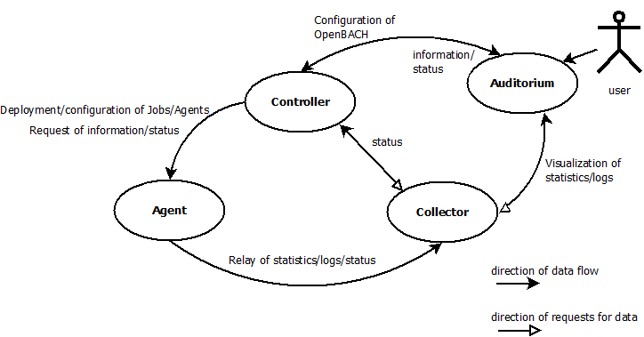Figure 1: OpenBach functional architecture | Synthesis of the activity:  - Deploy of a containerized C/S application on a distributed compute fabric (VMs)  - Environment setup (2 VMs)  - OpenBach experiment configuration  - Simple (centralized) statistics gathering  - Graphana/Prometheus integration  - Experiment configuration: L2, L3, App-L configuration setup capabilities

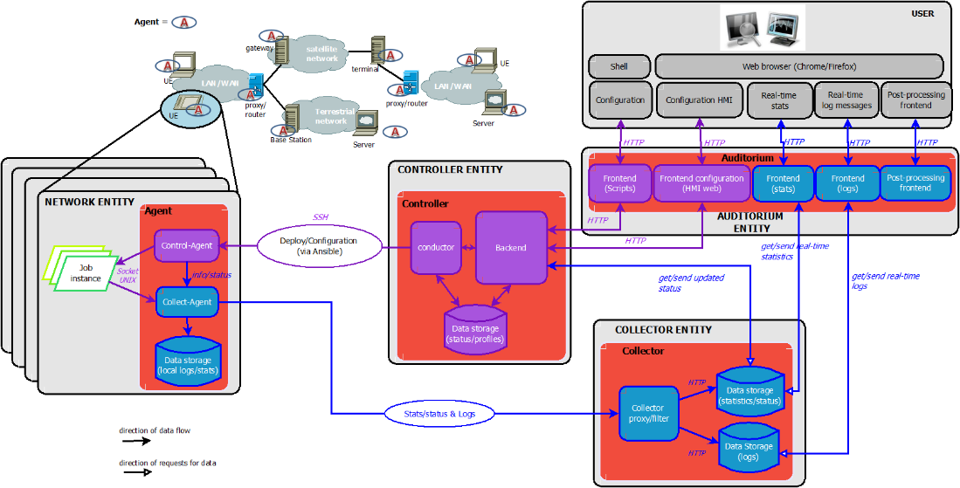Figure 2: OpenBach deployment architecture and functional components

